# SQLS3ExportStep

**Objective:**

It executes sql query which given by user and upload whole resultset into s3 based on the bucket name and file path and data in csv format.

**Attributes:**

|  |  |
| --- | --- |
| **Attributes** | **Description** |
| value | To enter the query to execute |
| value_type | To select type as free marker template or handlebar |
| output_variable | Used to store the response of the request |
| bucket_name | To give the particular bucket name in s3 to upload data |
| file_name | To give exact file path in s3 bucket to upload data |
| mysql_plugin_name | To connect with mysql server based on the plugin credentials |
| s3_plugin_name | To connect with aws amazon based access key and secret key which given plugin |

**Sample config.json:**

{

"workflows":[

{

"name":"sqls3export",

"id":1828,

"trigger":"rest",

"expression":"/sqls3export",

"method":"POST",

"steps":[

{

"type":"start",

"id":1,

"next":{

"start":"2"

}

},

{

"id": "2",

"type": "sql-s3-export",

"file_name": "test/testtable.csv",

"bucket_name": "appup-bucket",

"s3_plugin_name": "appup_bucket",

"value":"select * from user_info",

"value_type": "hb",

"output_variable": "result",

"mysql_plugin_name": "user_mysql",

"next":{

"success": "3",

"failure": "hangup"

}

},

{

"variable_name":"result",

"http_response_code":"200",

"response_content_type":"application/json",

"value_type":"hb",

"type":"send",

"id":"3",

"next":{

"success":"hangup",

"failure":"hangup"

}

}

]

}

],

"filters":[],

"server":{

},

"plugins":[

{

"id": 243,

"name": "user_mysql",

"type": "mysql-plugin",

"version": "1.0",

"category": "Database",

"server": "localhost",

"username": "root",

"password": "root",

"schema": "testDB"

},

{

"id": 25,

"name": "appup_bucket",

"type": "s3-plugin",

"version": "1.0",

"category": "storage",

"secretKey": "secretkey",

"region": "ap-south-1",

"accessKey": "accesskey"

}

]

}

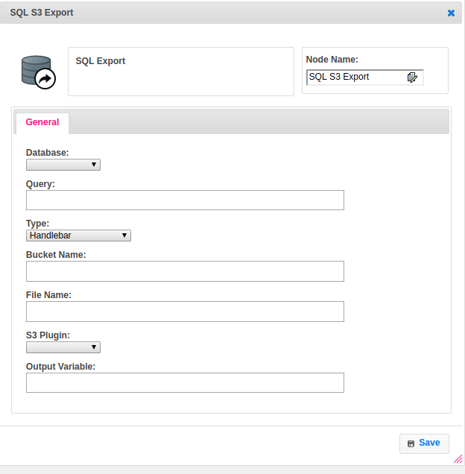

**Executor Description:**

* In executor class first it executes sql query and stores resultset into local temporary file as per headers in csv format by using csv printer.
* By using multipart upload the whole file will upload as chunks, each chunk partsize is 5mb. Retrieve ETag for each object part upload.
* After each individual part has been uploaded then pass the list of ETags to the request to complete the upload into s3.
* Based on the bucket name and file path the data will upload into particular file.